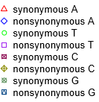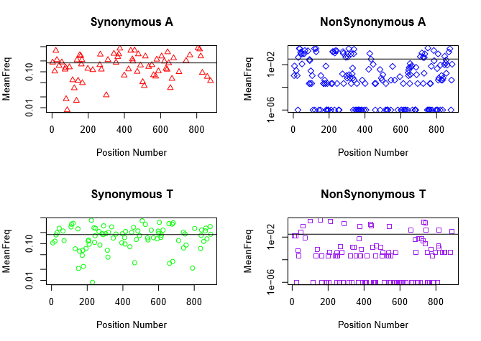

Enterovirus A

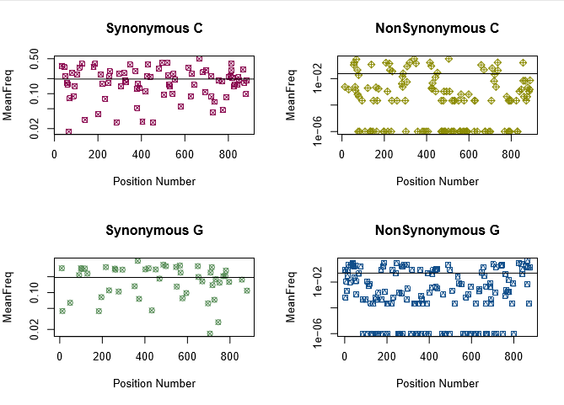

>gi|282765130|gb|GQ176232.1|CV_A4|Apr_1999|1999|Kenya|AF 891 bp

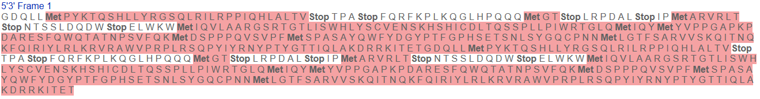

Enterovirus comes from the genus Picornaviridae. The VP1 protein is found in Enterovirus and is a capsid protein needed to begin viral infection. The VP1 protein interacts with sialic acid found on glycans. Enterovirus is a single stranded RNA virus that is transmitted through the intestines.

|  |  |
| --- | --- |
| Comparing | Wilcoxon rank sum test p-values |
| For a: Comparing makes CpG with noCpG (syn). Wilcox test less: red/blue | 0.0002415 |
| For a: Comparing CpG with noCpG (nonsyn). Wilcox test less: yellow/green | 0.5968 |
| For a: Comparing syn to nonsyn. Wilcox test greater red&blue vs yellow&green | 2.2e-16 |
| For t: Comparing makes CpG with noCpG (syn). Wilcox test less: red/blue | 0.02173 |
| For t: Comparing CpG with noCpG (nonsyn). Wilcox test less: yellow/green | 0.5097 |
| For t: Comparing syn to nonsyn. Wilcox test greater red&blue vs yellow&green | 2.2e-16 |

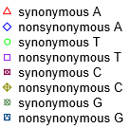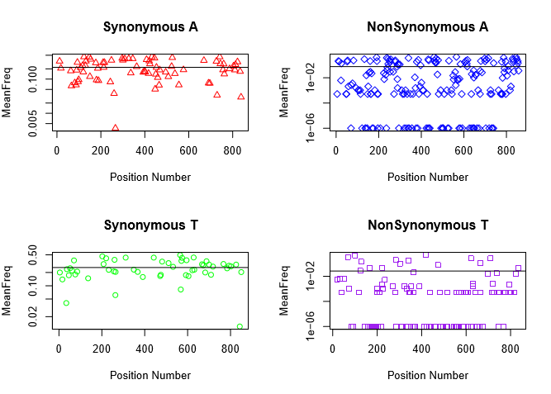

Entero B

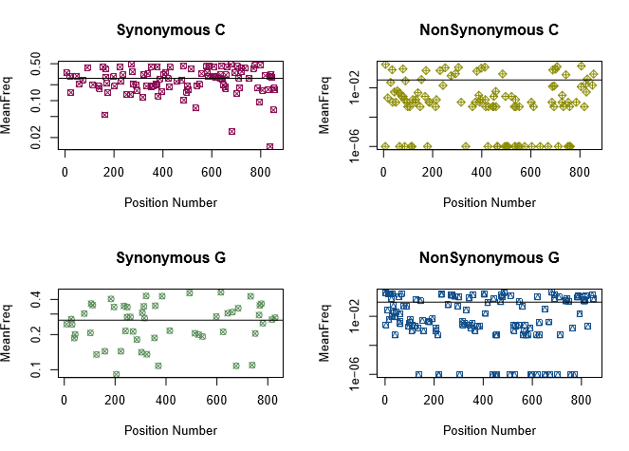

>gi|482514307|gb|KC570453.1|EV_A71|03_Jun_2012|2012|China|AS 863 bp



Enterovirus comes from the genus Picornaviridae. The VP1 protein is found in Enterovirus and is a capsid protein needed to begin viral infection. The VP1 protein interacts with sialic acid found on glycans. Enterovirus is a single stranded RNA virus that is transmitted through the intestines.

|  |  |
| --- | --- |
| Comparing | Wilcoxon rank sum test p-values |
| For a: Comparing makes CpG with noCpG (syn). Wilcox test less: red/blue | 0.1801 |
| For a: Comparing CpG with noCpG (nonsyn). Wilcox test less: yellow/green | 0.2282 |
| For a: Comparing syn to nonsyn. Wilcox test greater red&blue vs yellow&green | 0.9917 |
| For t: Comparing makes CpG with noCpG (syn). Wilcox test less: red/blue | 0.2324 |
| For t: Comparing CpG with noCpG (nonsyn). Wilcox test less: yellow/green | 0.9988 |
| For t: Comparing syn to nonsyn. Wilcox test greater red&blue vs yellow&green | 0.9984 |